Project 4 - A help interface

Jules Voltaire

CS3041

Prof. David Brown

04/14/16

The following XML File was read:

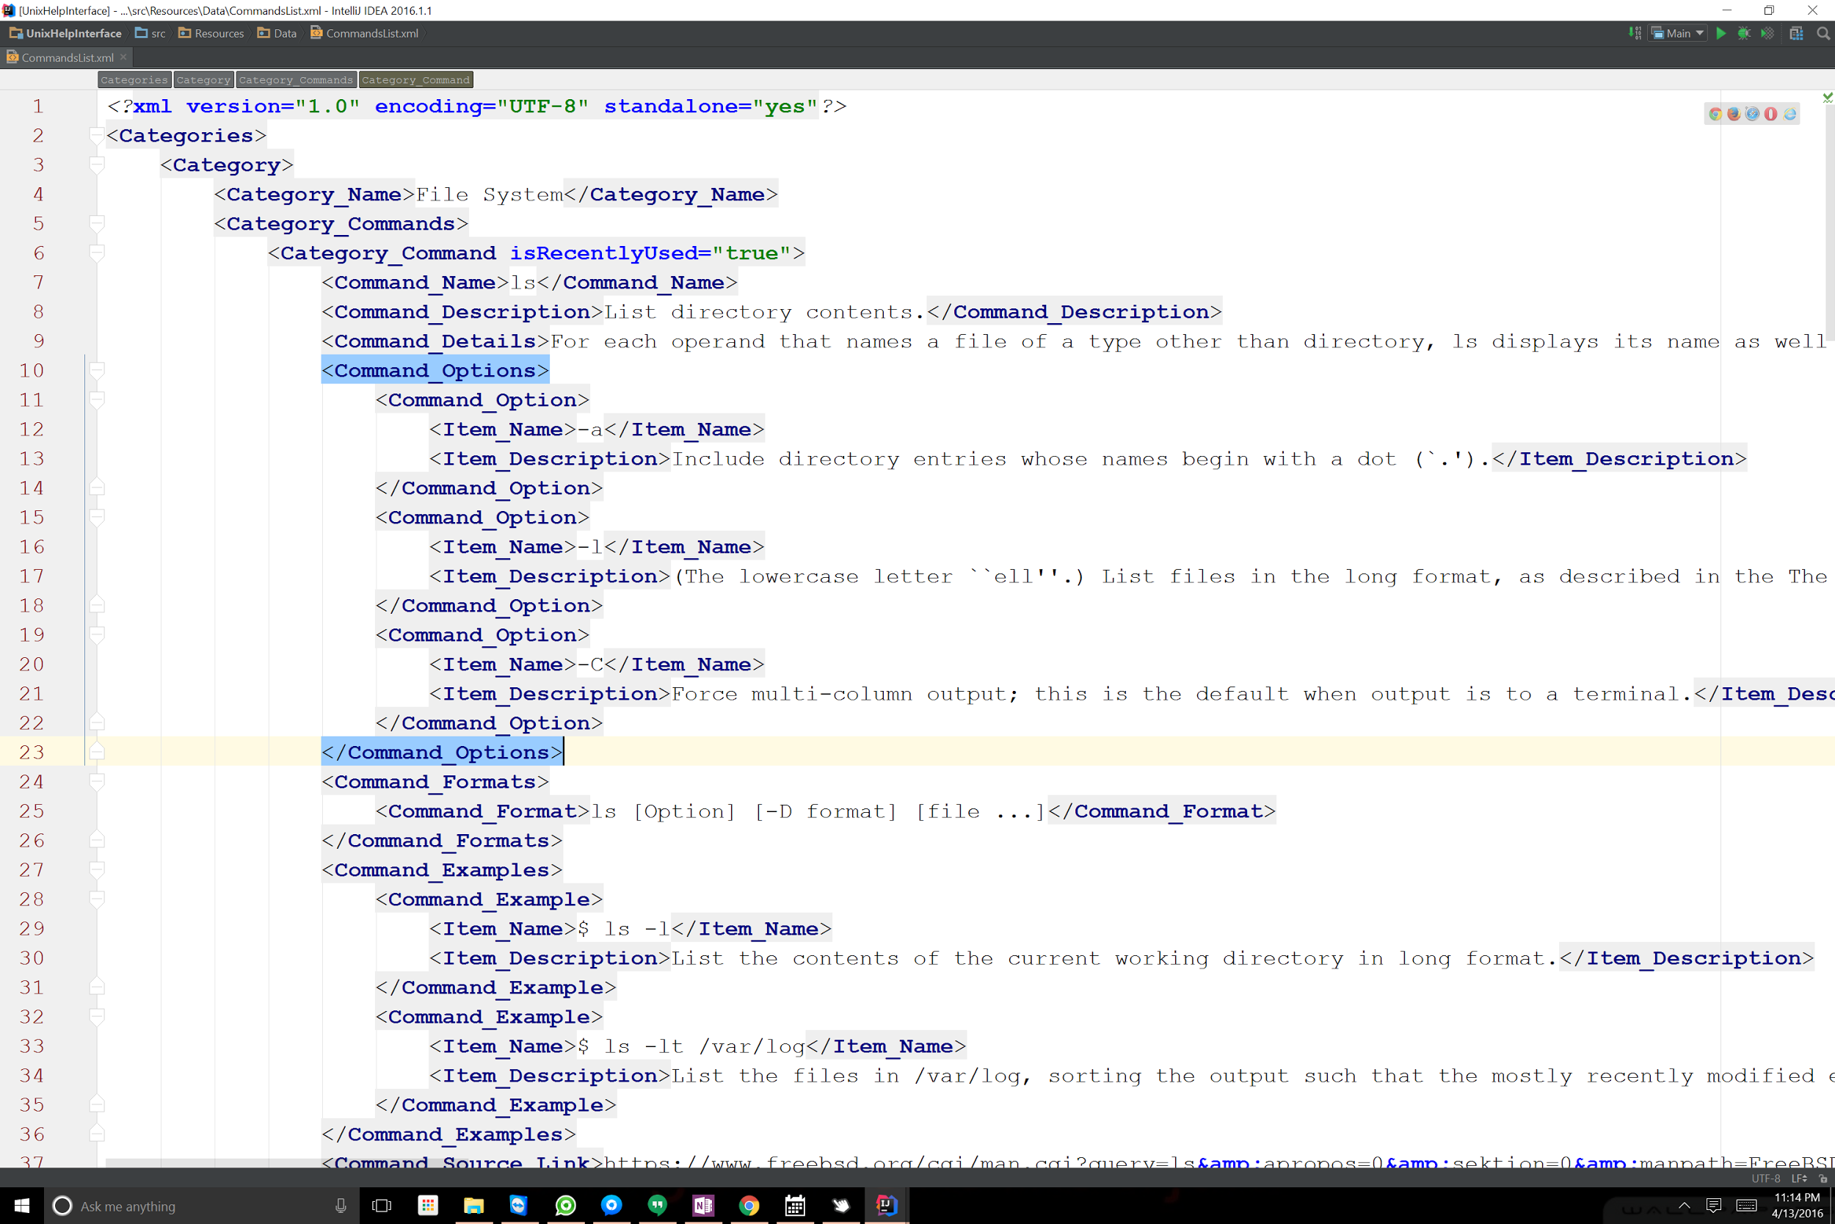

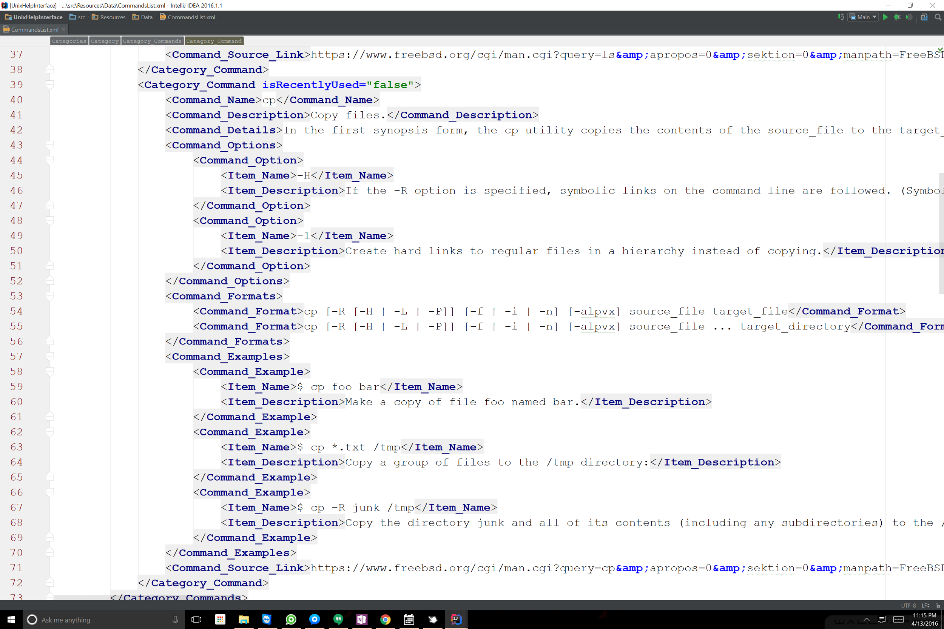 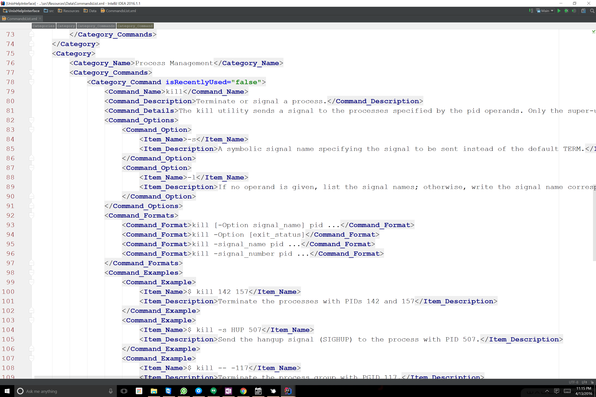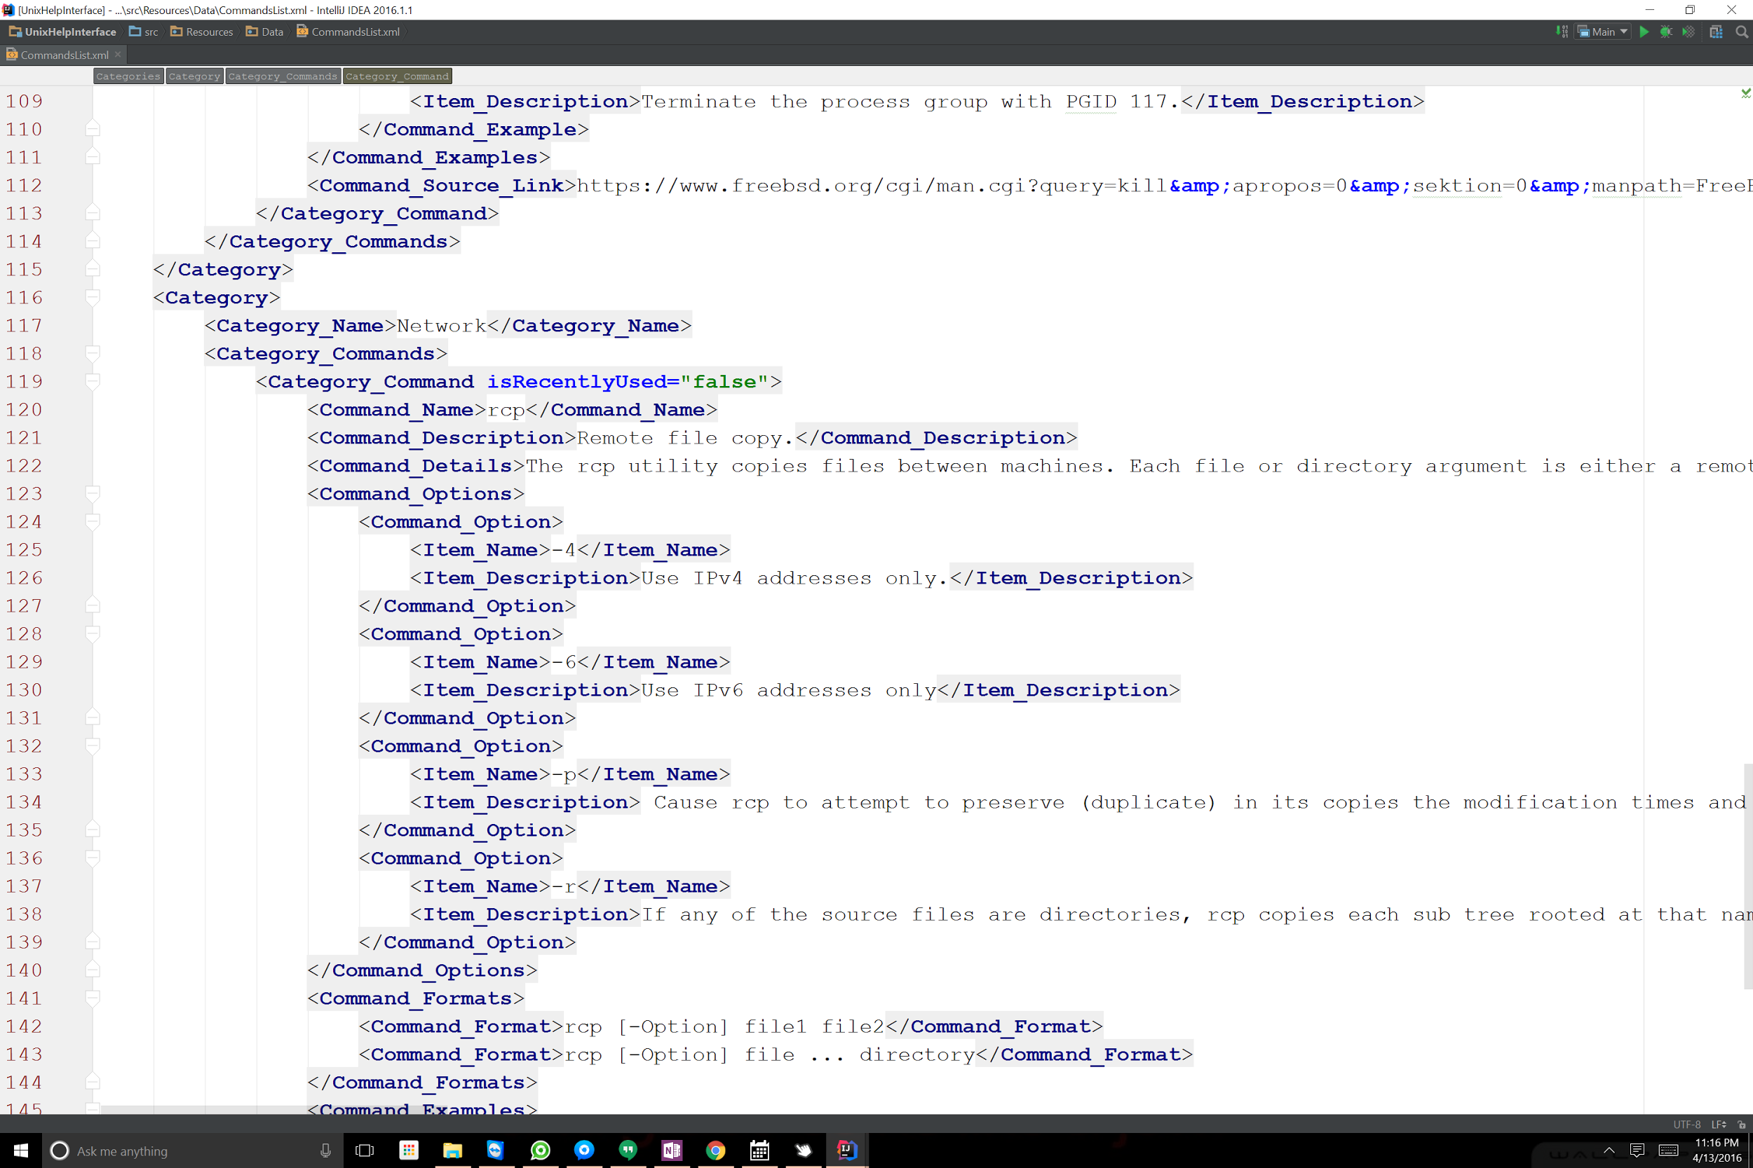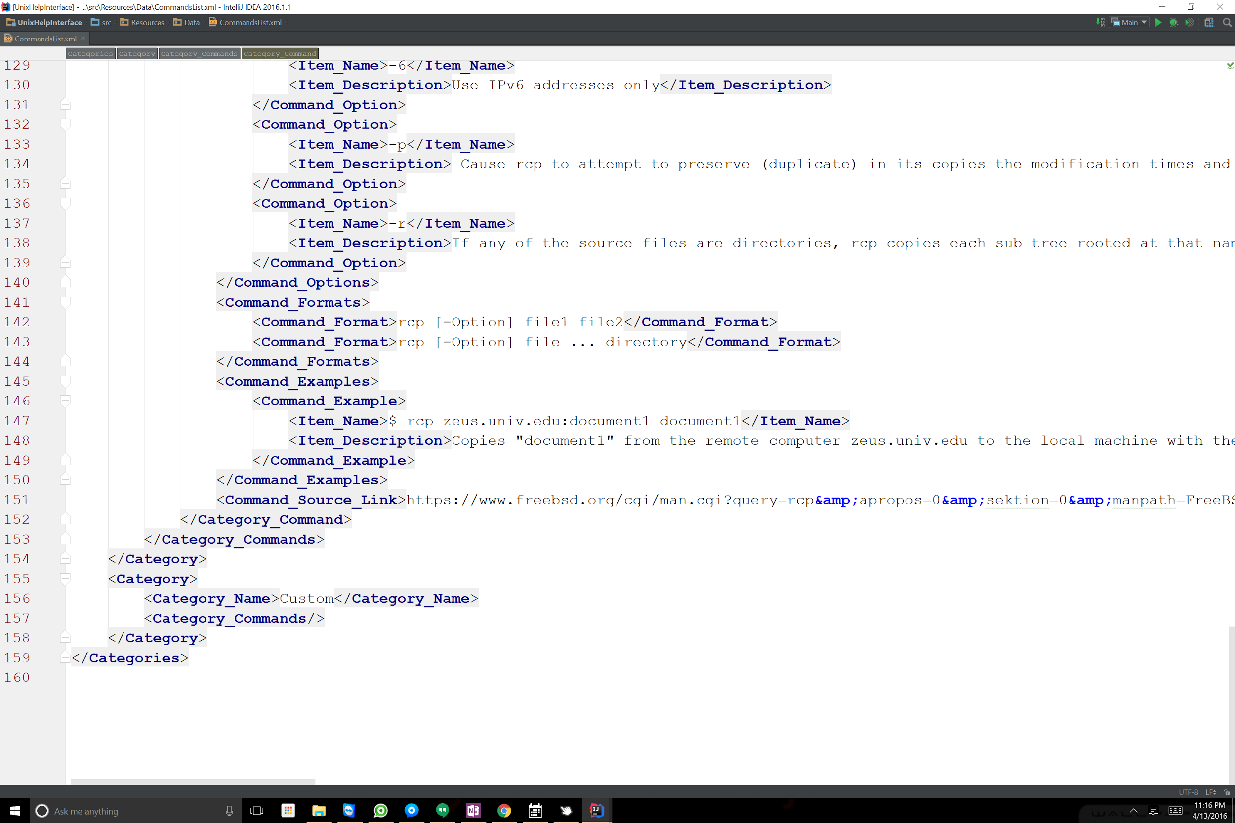

The output from printing the objects to the screen:

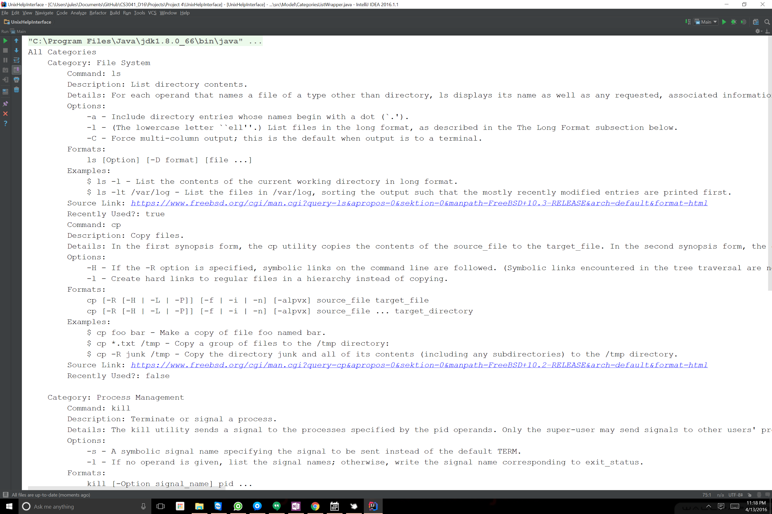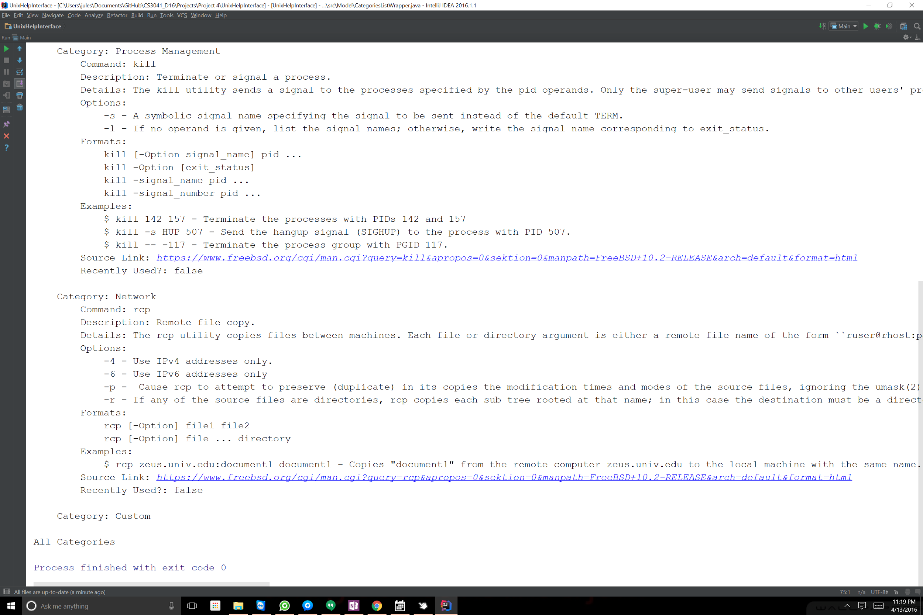

Displaying the objects data:

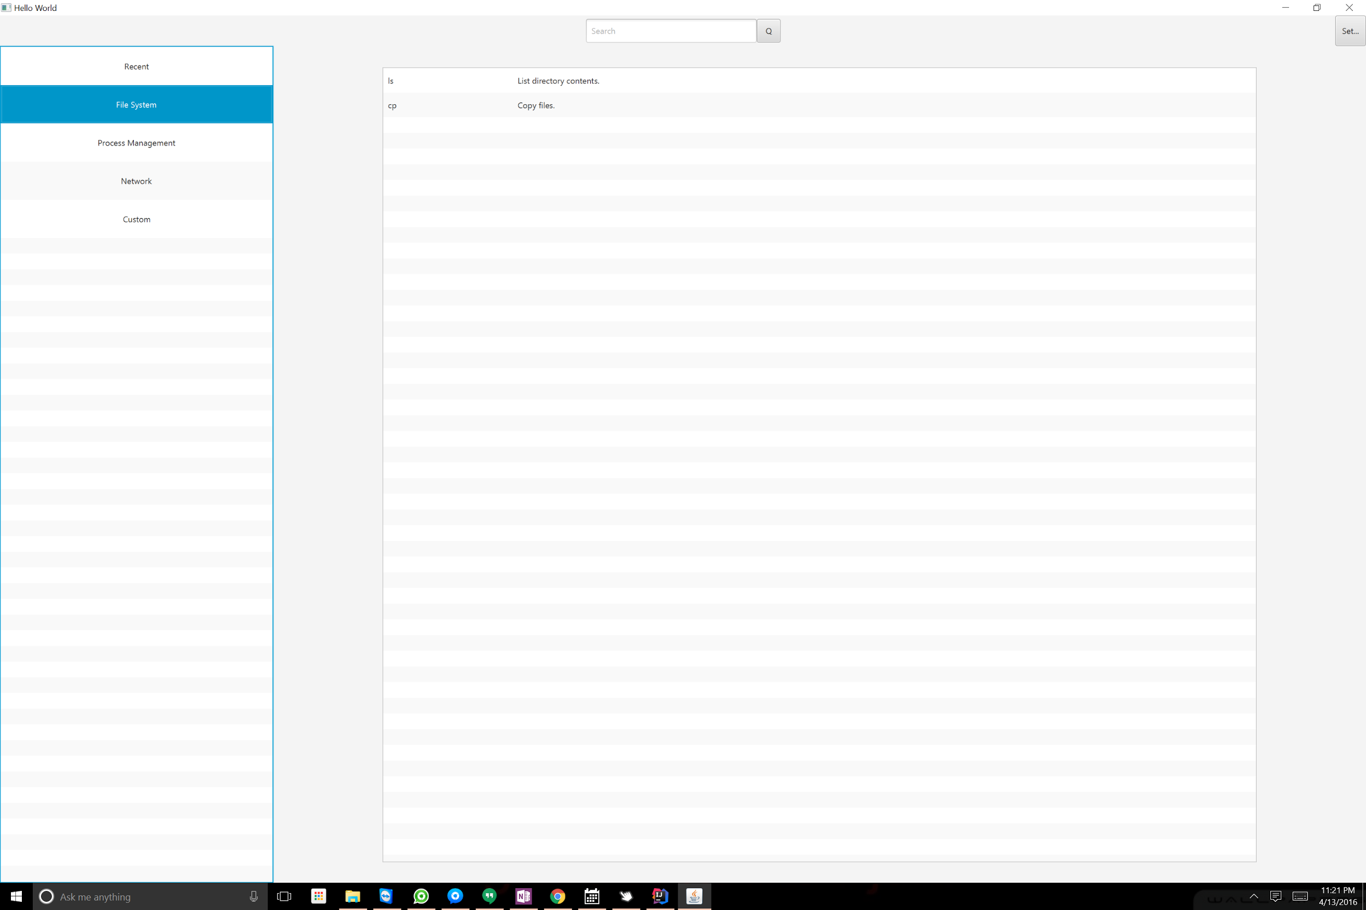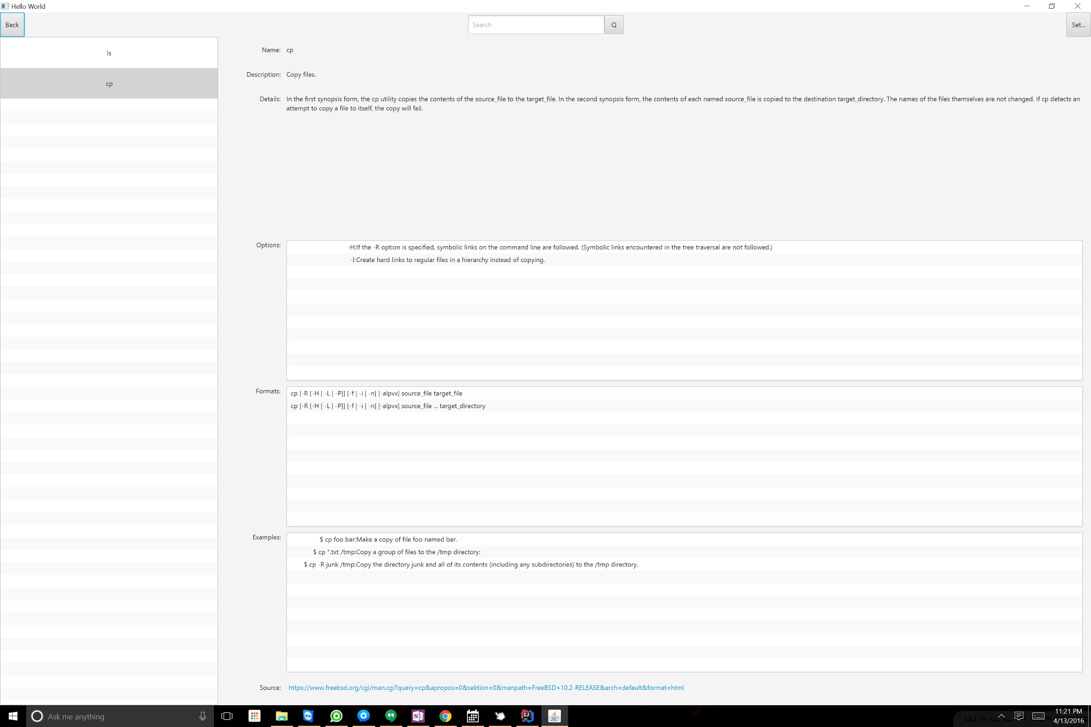

Some code Snippets:

This snippet will read the xml file and return an object containing a list of categories

**private** CategoriesListWrapper readXMLFile(){

**try** {

*// Creating the Marshaller*

JAXBContext jaxbContext = JAXBContext.*newInstance*(CategoriesListWrapper.**class**);

Unmarshaller jaxbUnmarshaller = jaxbContext.createUnmarshaller();

*// Creatinga CategoriesListWrapper object from the file.*

**return** (CategoriesListWrapper) jaxbUnmarshaller.unmarshal(**XMLfile**);

} **catch** (JAXBException e) {

e.printStackTrace();

}

**return null**;

}